**Sheet 5**

**Discrete Systems & Convolution**

1. A discrete system can 1) linear or non linear 2) casual or non casual

Examine the following systems with respect to the properties above.

1. Y(n) = cos(x[n])

Ans: nonlinear, causal.

1. Y(n) = x(-n + 2)

Ans : linear, noncausal.

1. y(n)=x(2n)

Ans: linear, noncausal.

1. y(n) = |x(n)|

Ans: nonlinear, causal.

1. y(n) =Round[ x(n)] integer part of x(n)

Ans: nonlinear, causal.

1. Compute the convolution y(n) = x(n) * h(n)

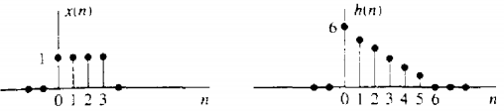

1. Compute the convolution y(n) = x(n) * h(n)

